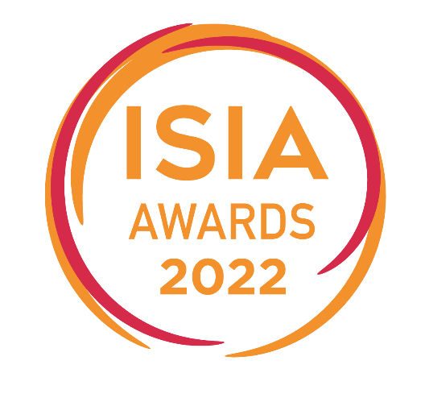

15th of October at Carton House

Company Name: _____________________________________________________

Contact Person: ______________________________________________________

Tel: __________________________ Email: ________________________________

We would like to book ____ seats/tables at the ISIA Awards 2022

Cost of Tickets: €€270 per person or €2500 per table of 10 plus VAT @ 23%

***ISIA Members Only Early Bird Rate Offer***

Book your tickets by the 26th of August 2022 and pay the following early bird rate:

Cost of Tickets: €240 per person or €2250 per table of 10 plus VAT @ 23%

I understand that I will be invoiced for the amount due and that the amount must be paid in full by the 16th of September 2022.

Account Department Contact Name: ______________________________________

Tel: _________________________ Email: ________________________________

I confirm that I have authorisation to book seats/tables at this event.

Name: ______________________________________________________________

Signature: ___________________________________________________________

Please scan and email form to awards@isia.ie

Irish Security Industry Association
Chase House, City Junction Business Park,
Northern Cross, Malahide Road, Dublin 17
For further information on the ISIA Awards 2016 please contact:
Sarah O’Donnell Email: sarahodonnell@isia.ie Tel: 01-4847206 Mobile: 087-2229127 or awards@isia.ie

